JAVA & JENKINS VERSION VERIFICATION:-

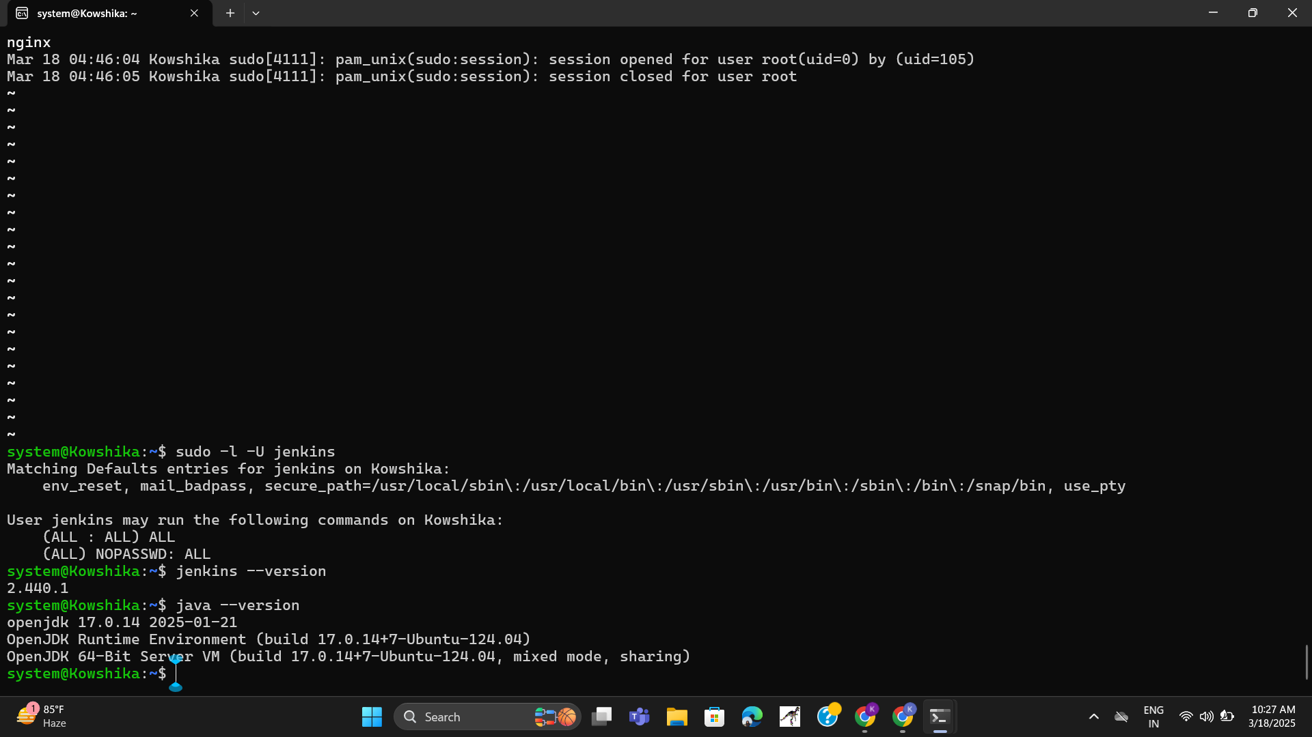

IPADDRESS VALIDATION PAGE:-

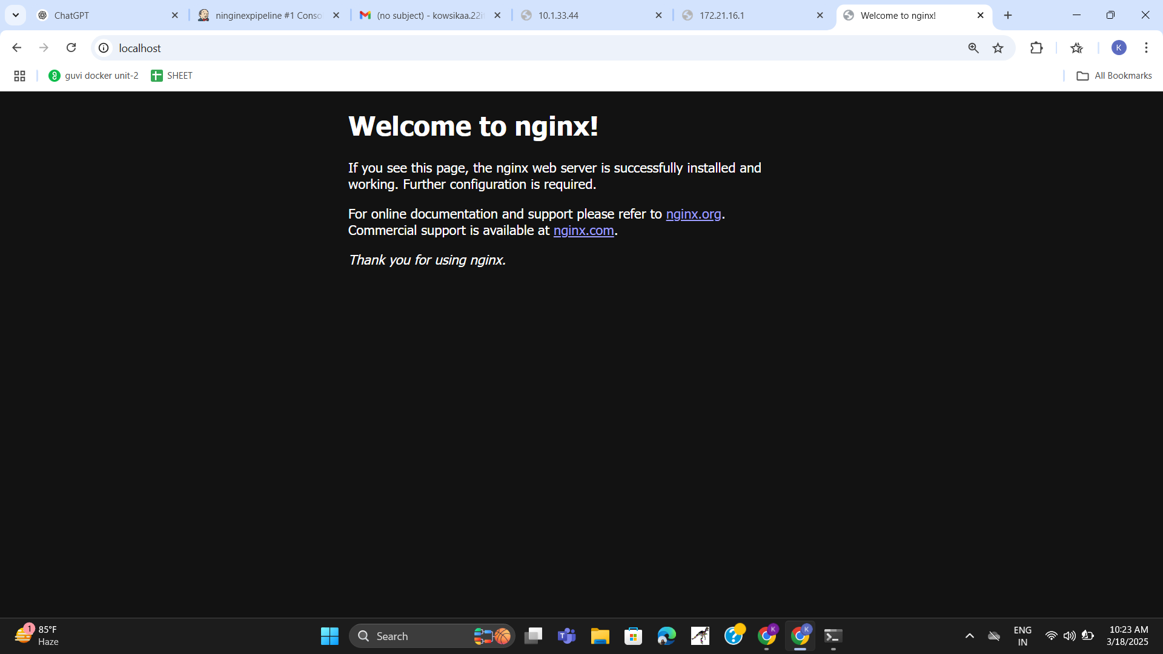

BUILD SUCCESS PAGE & LOCALHOST 8080 RUNNING PAGE:-

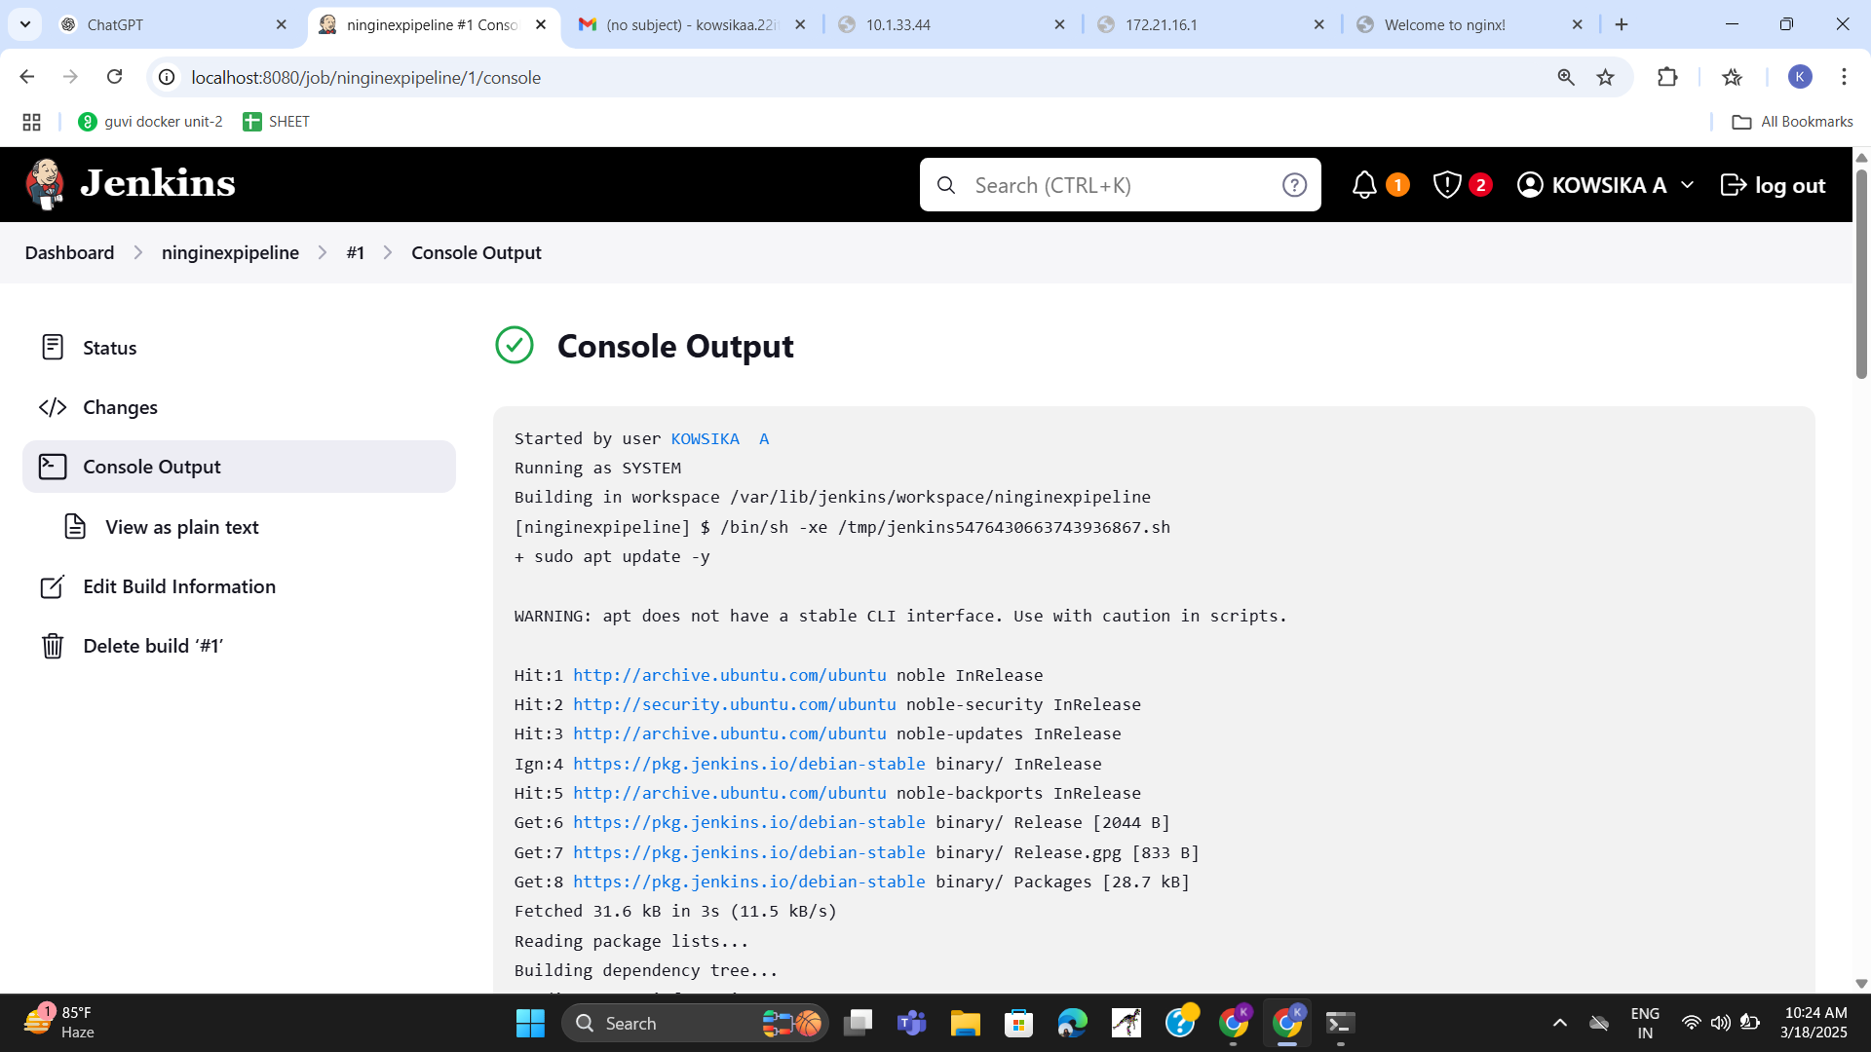

JENKINS SERVICE PAGE:-

